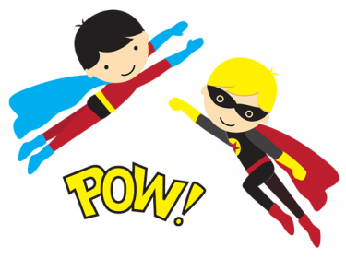
School Supplies
Grades 5th-6th

- 1 King James version bible
- 1 school box, large enough to hold all supplies
- 1 black sharpie marker
- 1 large backpack
- 24 #2 pencils
- 1 pair scissors
- 1 ruler with centimeter and inch markings
- 2 2-pocket folders – any design
- 5 spiral notebooks
- 1 3-ring binder (for notebook paper)
- 3 boxes of Kleenex
- 1 pack red grading pencils
- 1 package colored pencils
- 1 packages dry erase markers
- 1 package Crayola brand washable markers
- 1 bottle of hand sanitizer
- 2 Packages wide rule notebook paper
- 1 package graph paper
- 1 package pens blue or black
- 2 packages index cards
- 1 compass & protractor
- Black shorts (to the knee) or wind pants for gym

